OPERATING MANUAL,
MODIS EDGE MAIN PCB SCOPE
FUNCTIONAL TEST HEAD

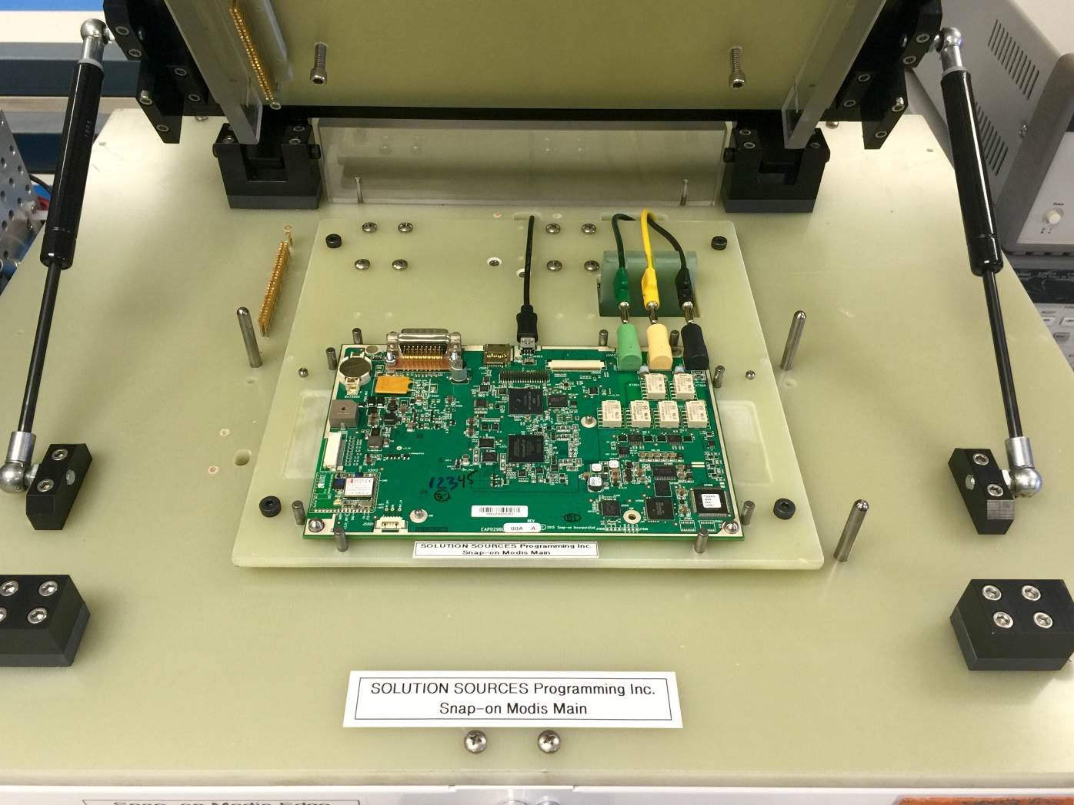

Revision Tracking
REV | DESCRIPTION | EDITOR | DATE | Approved By
0 | Initial Release | Pam Jezek | 05/17/2016 | Pam Jezek

TABLE OF CONTENTS Page
- INTRODUCTION 4
1.1 Purpose 4
1.2 Intended Audience 4
1.3 Overview 4
1.4 Parts Tested With This Test Head 5

2. ENVIRONMENTAL OPERATING CONDITION REQUIREMENTS 5
2.1 Environmental Requirements 5
2.2 Utility Requirements 6

3. MAINTENANCE 6
3.1 Scheduled Maintenance 6

4.0 CALIBRATION 6
4.1 Instruments Require Calibration 6

5.0 OPERATING PROCEDURES 6
5.1 Launch Software Program 6
5.2 Run an Automated Test 9
5.3 Exit 16
5.4 Test Reports 16
5.5 Test Results Log Files 17
5.6 COM Port Configuration File 17
5.7 Administrator Log in 18
Appendix A 19

5.8 Software Installation 21

INTRODUCTION

Purpose
This document specifies the operating procedure for the Modis Edge Main PCB Scope Functional Test Head.

Intended Audience
The intended audience of this document includes operators, technicians and engineers who use the Modis Edge Main PCB Scope Functional Test Head.

Overview
This document is organized as follows:
- Section 1, INTRODUCTION, describes the purpose of this document.
- Section 2, ENVIRONMENTAL OPERATING CONDITION REQUIREMENTS, specifies the operating conditions and utilities required when operating the Test Head.
- Section 3, MAINTENANCE, specifies maintenance procedures.
- Section 4, CALIBRATION, specifies parts that require calibration and the frequency of recalibration.
- Section 5, SOFTWARE OPERATION, provides detailed, step-by-step instructions for using the Test Head software.
- Appendix A includes a sample test report.

Parts Tested with This Test Head

The Functional Test Head performs the Scope calibration and verification process for the Modis Edge Main PCB.
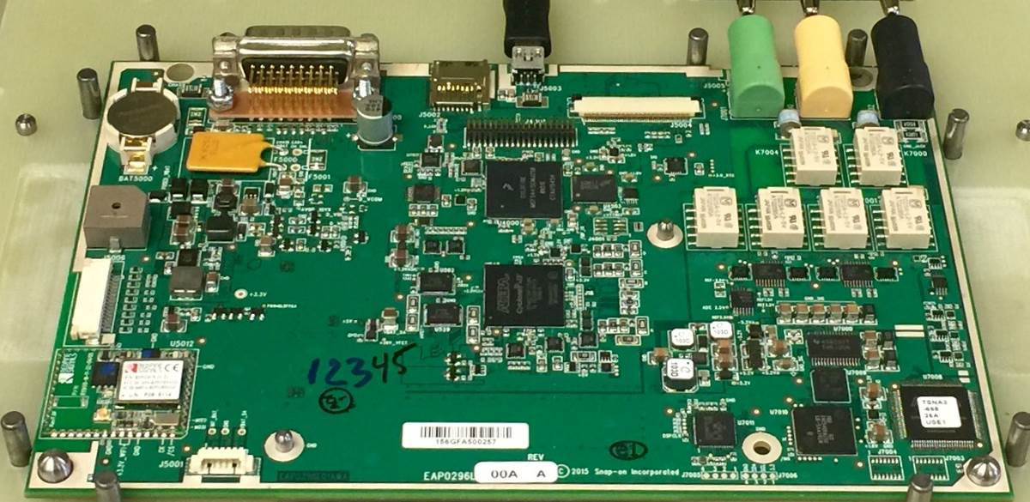

ENVIRONMENTAL OPERATING CONDITION REQUIREMENTS

Environmental Requirements

The Modis Edge Main PCB Scope Functional Test Head is designed to operate in an electronics manufacturing facility or engineering lab environment with the following conditions.
Condition | Limits
Operating Temperature | 10 to 45 °C
Relative Humidity | 10 to 80% RH, noncondensing

Utility Requirements

The test head is designed to work with the existing Scope Test Rack and cannot be operated without the Scope Test Rack.

The test fixture requires standard 110/220VAC, 50/60Hz electrical power. The power entry module is located on the rear panel of the fixture.

The test fixture requires standard clean, dry compressed air. The compressed air fitting is located on the rear panel of the fixture.
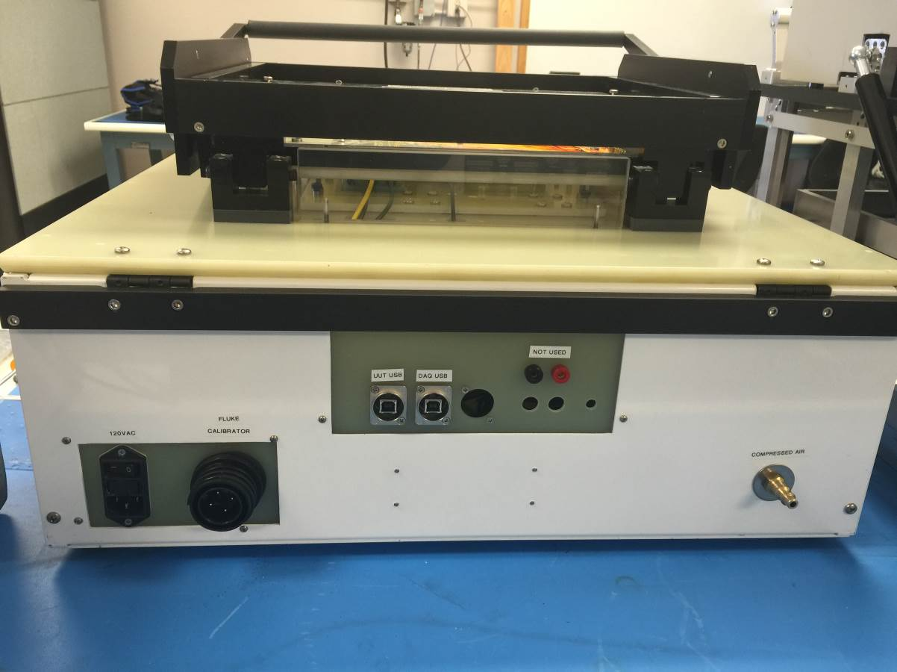
DAQ USB Cable
UUT USB Cable
Compressed Air Fitting
120VAC Power Entry Module
Fluke Calibrator Cable

MAINTENANCE
  - Monthly Scheduled Maintenance

Worn parts should be replaced as necessary. Parts that are likely to wear with use are listed in the Recommended Spare Parts List.

INSTRUMENT CALIBRATION

The following instruments require calibration:
Model No. | Description | Calibration Interval
USB-6343 | X Series Data Acquisition, National Instruments | 2 years
5080A | Fluke, Calibrator | 1 year

OPERATING PROCEDURE

Launch Software Program
5.1.0 Prior to launch the Snap-On Modis Edge Main PCB Scope test program on a new PC, refer to the Initial CyUsb Driver Installation document for the initial installation of the Cypress driver on the factory Test PC for the M5 Scope hardware. Note that the M2 ignition scope module driver will not work at on a 64-bit operating system.
5.1.1 Find the 5080A Fluke “USB drivers for Windows, Rev II” CD and run the set up program to install
the driver for the instrument. Once the installation finishes, COM3 is automatically shown under
device manager. You can also find the USB driver from the manufacturer website.
5.1.2 If the COM port is changed differently, refer to step 5.1.3 to change the COM port number.
5.1.3 Right-Click my computer >> select Device Manager >> click on the port and goes to properties.
Click Advanced tab and select COM 3 and press OK.

    - Click on port settings tab and select COM3 and press OK.
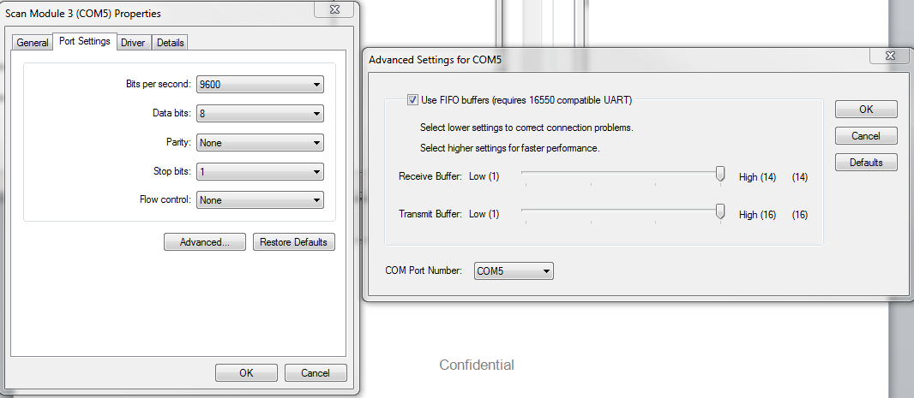
Click OK button to start test.

To launch the software program, click on the shortcut Modis Edge Scope on Windows desktop.

When the program is launches, the scan fixture screen is displayed as shown below.
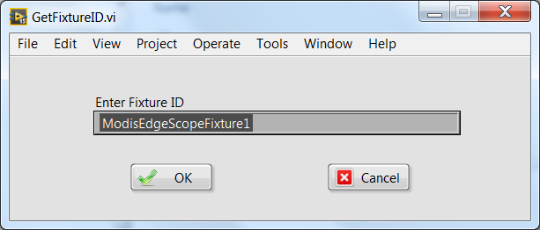
Fixture ID manual text entry is allowed. The recommended text entry is to use the bar code scanner. The default Fixture ID is read from an configuration file (ModisEdge.ini) with key Name FixtureID = "ModisEdgeScopeFixture1" under [Main] section. If the operator clicks on Cancel button, the default fixture ID will be used ignoring any entered text. Click OK button to accept text entry.

Scan the barcode on the front of the fixture into the Fixture Serial Number field in the window above.
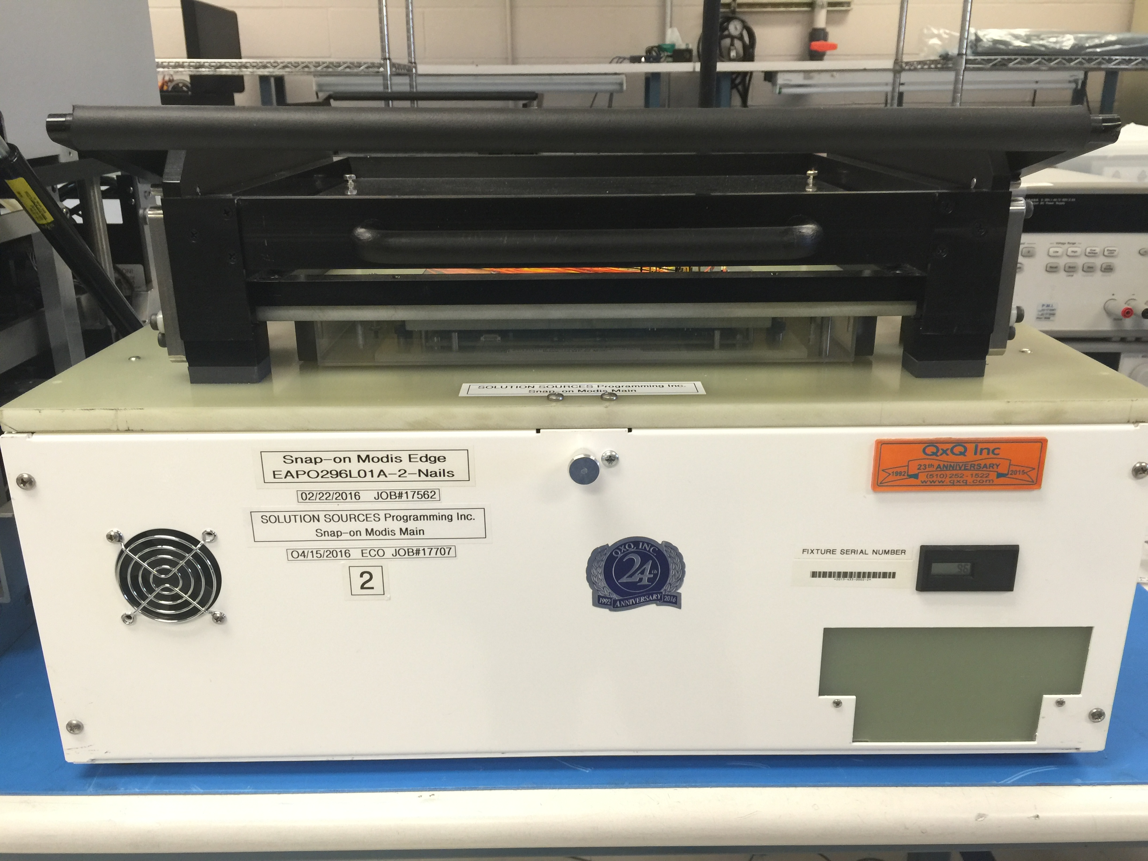
Scan Fixture Barcode

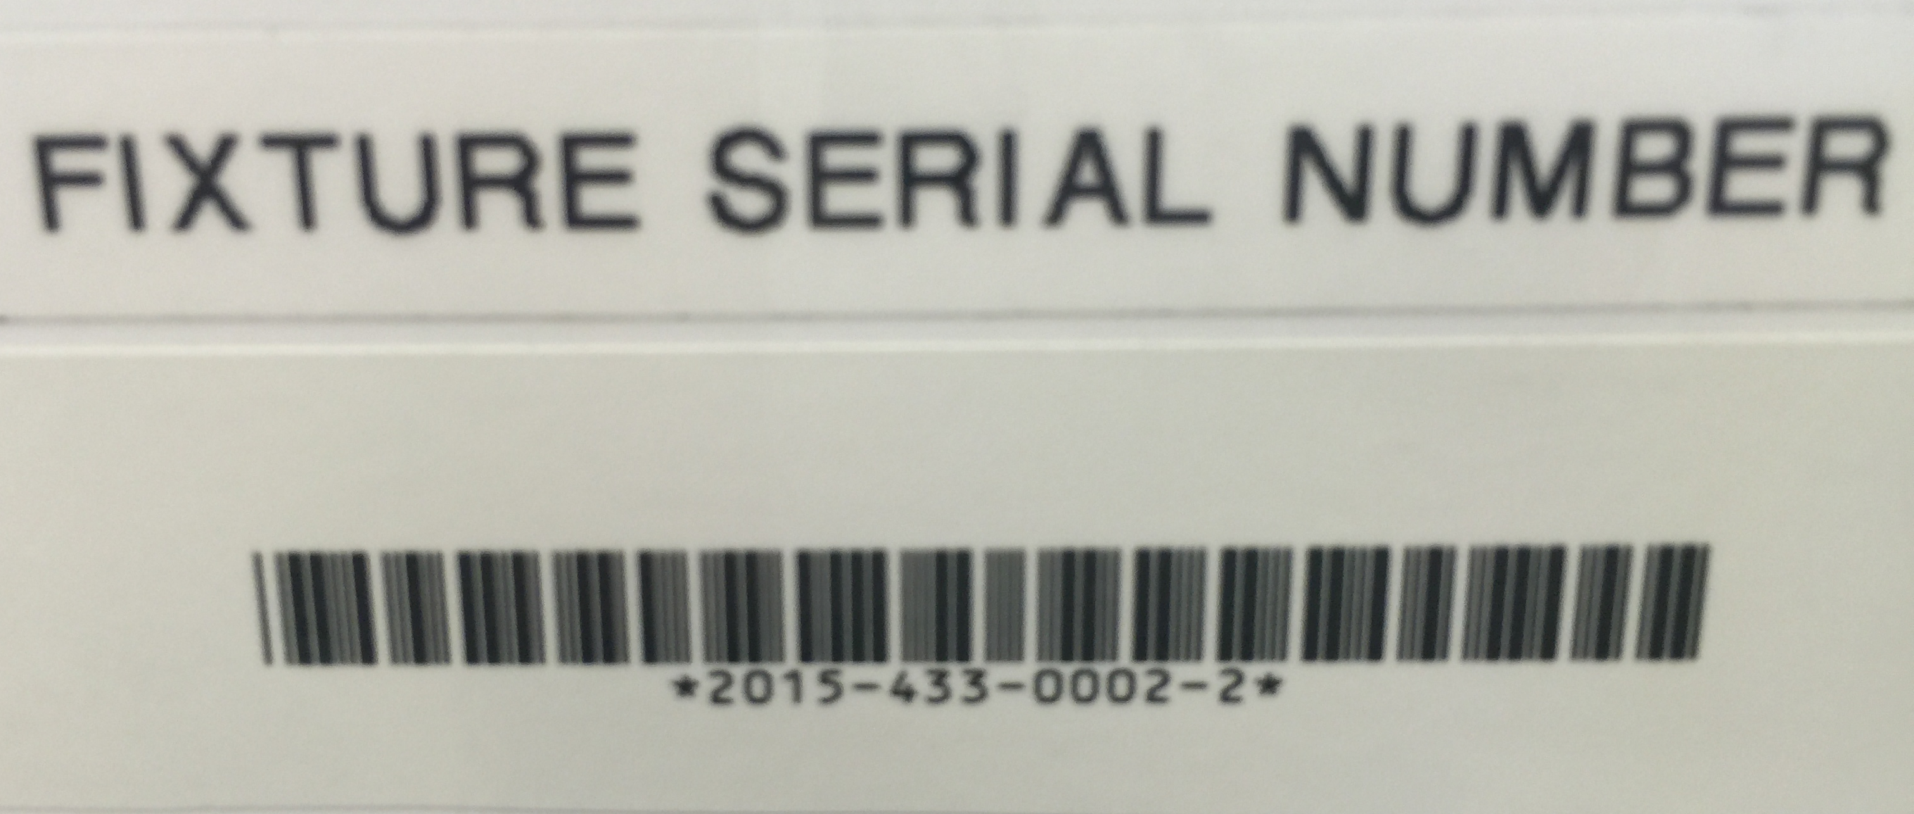

When the fixture barcode has been scanned, the login screen is displayed as shown below. The TestStand login window shown below is displayed on top of the main test screen. User Name Operator will appear by default. The password is “operator”. Click the OK button.
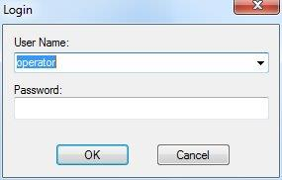

If you launch the application and decide not to login, click the Cancel button on the Login screen. The entire application closes and returns to the Windows desktop.

After logging in, the main test screen is displayed as shown below.

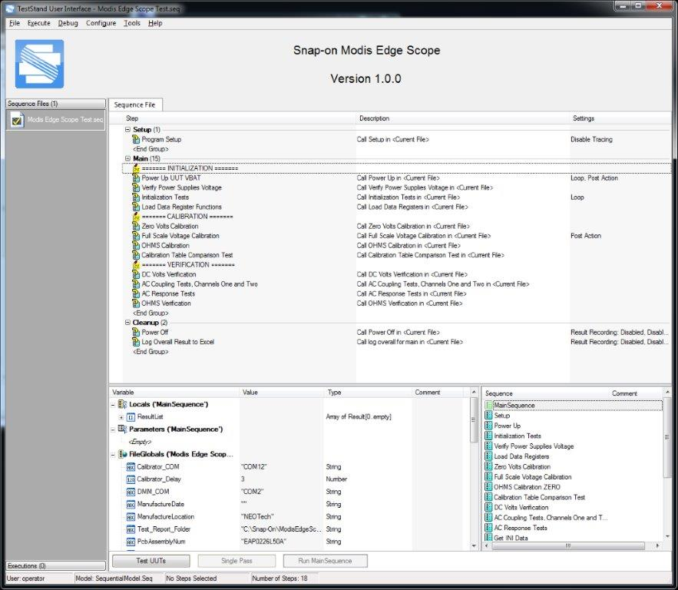

Run an Automated Test

Click the Test UUTs button.
Click Test UUTs button to start test.

Place DUT into the fixture as shown
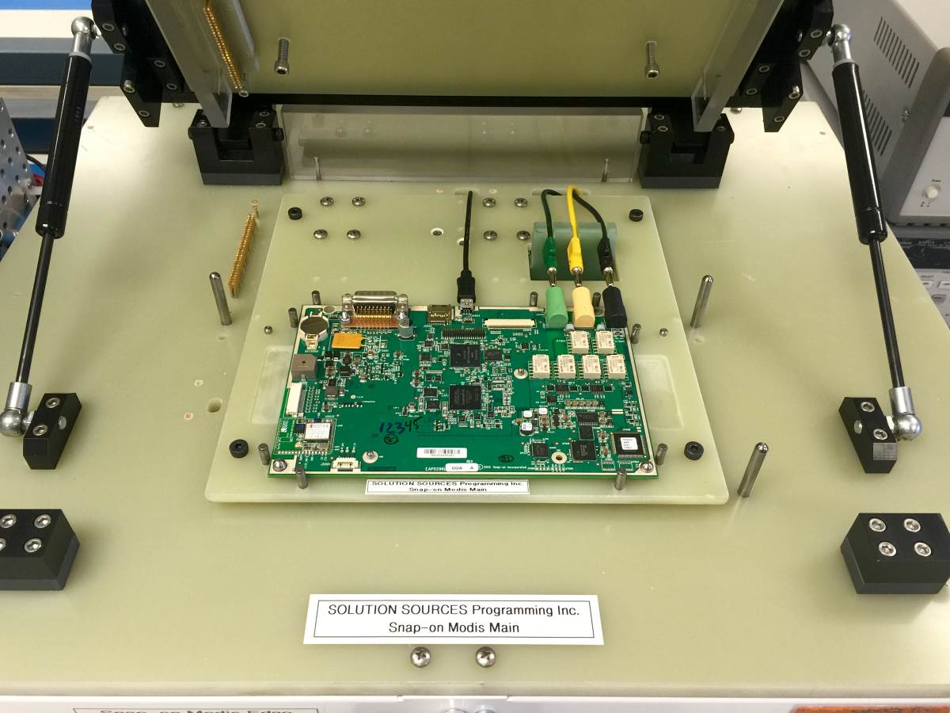

The software will display the following UUT Information window. Use the barcode scanner to scan the UUT’s serial number into the field labeled Enter UUT Serial Number.
Tooling Pin
Tooling Pin
Tooling Pin
Tooling Pin
Connect USB Cable

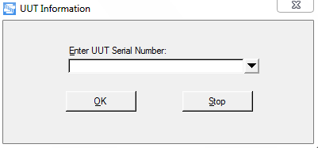
Click OK button to start test.

Press [OK] on the UUT Serial Number display to continue.

When the following message appears, close the fixture lid. If the lid is not fully closed, the test will fail at the Measure Interlock Voltage test step.
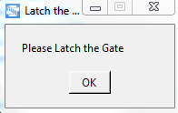

The Program will start testing the Modis Edge Main PCB and will display the test step status throughout the test.

When the test sequence is complete, the main test screen will display the final PASSED/FAILED result.

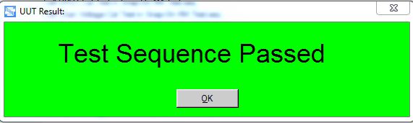

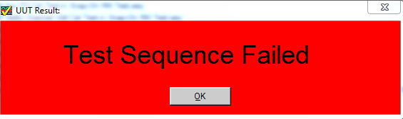

    - Click OK and print test result
    - Insert next UUT.
5.3 Exit
    - To exit the Test Head software, click the Exit button.
    - The software closes any “open instrument references” and then closes the program.
  - Test Reports
    - The Test Head software produces a .txt format test report for each test run. See Appendix A for a screen shot of a partial sample report.
      - The test reports resides in directory
C:\Snap-On\Modis Edge Main PCB Scope
    - The files names follow this text format:
Snap-On Modis Edge Main PCB Scope Test_Report [serial number][timestamp][date]_.txt
For example: Snap-On Modis Edge Main PCB Scope Test_Report[V14236090][6 08 17 PM][4 22 2015]_.txt
  - Test Results Log Files
    - The Test Head software produces monthly Excel log files of the day’s test results and resides in directory
C:\Snap-On\Modis Edge Main PCB Scope
    - The Snap-On Modis Edge Main PCB ScopeExcel monthly file name follows this format
Modis Edge Main PCB Scope Test Results_2015-04.xlsx
  - COM Port Configuration File
    - The Test Head software reads the TabletScopeMFG.ini file (C:\Program Files\Snap-On Tablet Scope) to set UUT information and configure test instruments device names for the Fluke Calibrator 5080 and NI DAQ USB-6343.
Note that DMM is not used at the current test program.
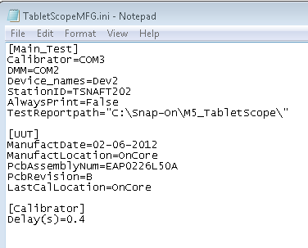
    - Dev2 is currently assigned for NI-DAQ 6343 device. The multifunction DAQ is used to control high voltage relays and routes stimulus signals from the Fluke Calibrator to the DUT.
    - Calibrator is remotely control through USB-RS232 @ COM3 to provide stimulus voltages during the test.
    - StationID identifies the Test Head number.
    - Calibrator Delay(s) controls the unsettled time of the calibrator when the outputs was changed within the specified accuracy.
Note: If calibration data occasionally fails at Voltage and Ohm Verification, it’s most likely that the Calibrator’s unsettled time needs to be adjusted.

  - Administrator Login
    - At the TestStand Login window shown below, click the pull down button and change the User Name to Administrator. The password is “solution”. Click the OK button.

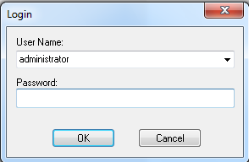
5.7.2 At the current stage, the functional test program are not implemented to run in the debug mode.

Appendix A – Sample Test Report

A sample of Pass/Fail Test Report

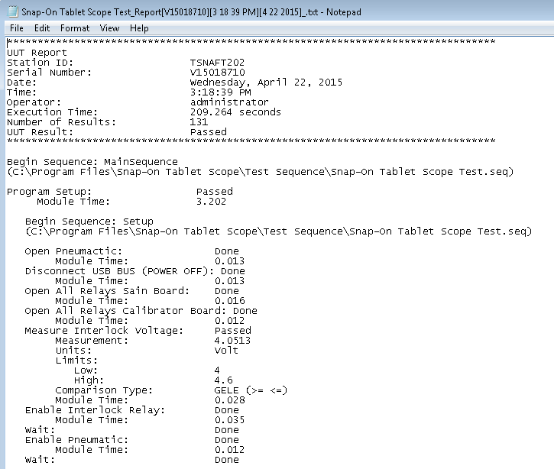

5.8 Software Installation
5.9.1 Insert the DVD labeled “Installer” and run the setup file. You may have to wait a few moments while
the installer loads. Click Next to begin
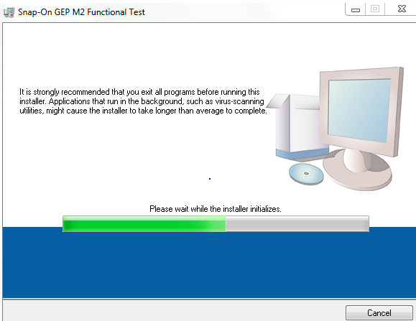

5.9.2 Select the destination folder that you want to install your tests. Press Next to continue
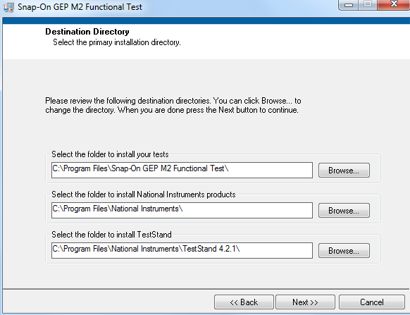
5.9.3 Accept the License Agreement(s) and then click Next.
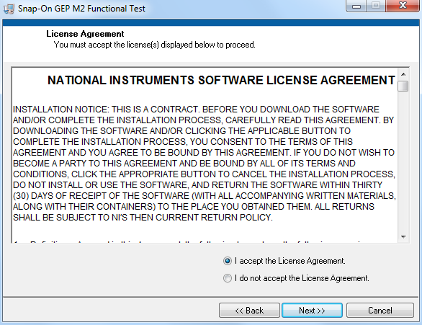
    - Follow the instructions on the screen to finish the installation.

